**FRESH CRANBERRY BEANS WITH OLIVE OIL & GARLIC**

BY [**MAYIHAVETHATRECIPE**](http://mayihavethatrecipe.com/author/mayihavethatrecipe/) ON NOVEMBER 26, 2012 IN [**GLUTEN FREE**](http://mayihavethatrecipe.com/category/gluten-free-2/), [**GRAINS AND BEANS**](http://mayihavethatrecipe.com/category/grains-and-beans/), [**KOSHER**](http://mayihavethatrecipe.com/category/kosher/), [**PARVE**](http://mayihavethatrecipe.com/category/parve/), [**VEGAN**](http://mayihavethatrecipe.com/category/vegan/),[**VEGETARIAN**](http://mayihavethatrecipe.com/category/vegetarian/)

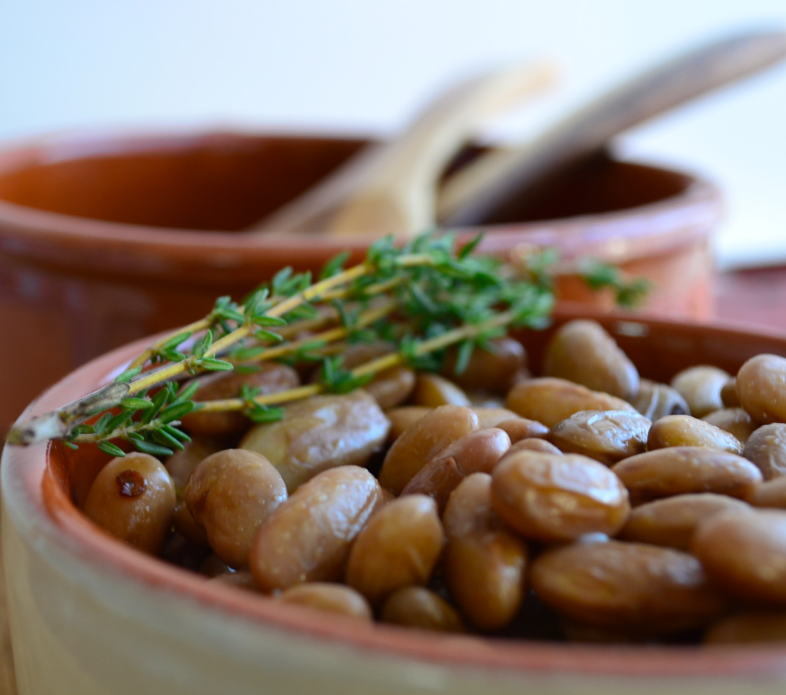

Have you ever heard of cranberry beans?

I know, I know. Thanksgiving has already come and gone, and between all the prepping, the eating and the leftovers, you probably don’t wanna hear the word cranberry till next year…

But don’t worry, cranberry beans actually have nothing to do with cranberries. They’re beans that have this really cool deep pinkish red color when fresh (hence the name) and a nice nutty flavor.

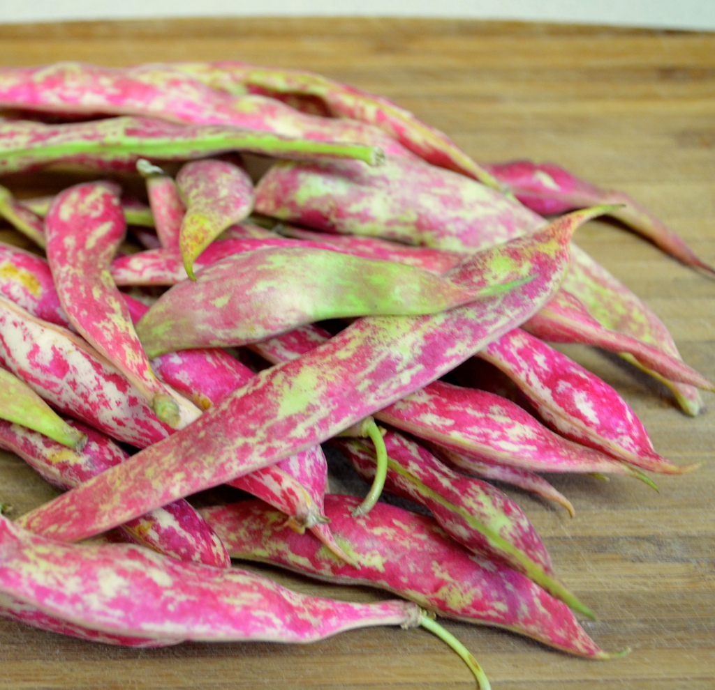

I had never heard of them before, but happened to find them the other day at the market and I couldn’t resist. They looked so pretty, I had to buy them. I had no idea what they would look like on the inside, or what they would taste like, but you know how much I love experimenting, so I figured I would give them a try anyway.

So when I got home, I opened up the pods, and these little guys were inside. Really cool looking, aren’t they?

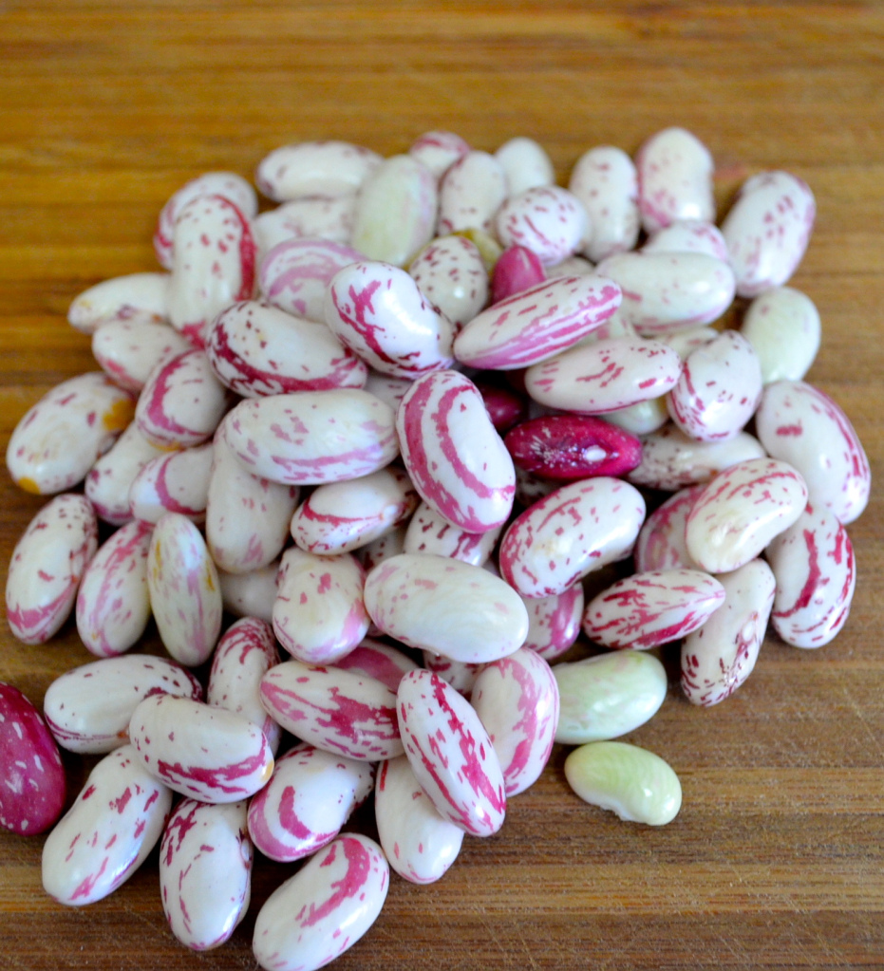

I was trying to figure out what to do with them, when the light went on. I remembered a friend of mine from college, originally from the northern part of Spain, who taught me how they cook fresh black beans in his hometown. Super simple, but bursting with flavor.

Hope you like it :)

Vicky

**[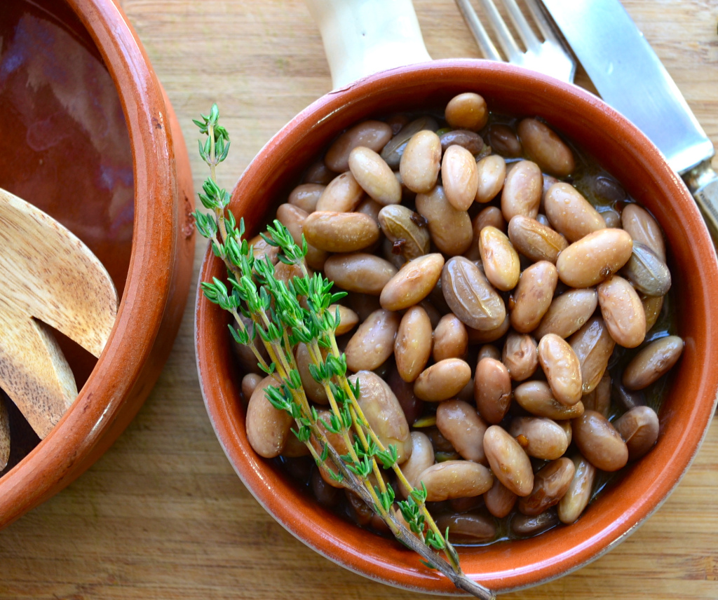](http://testmayihavethatrecipe.files.wordpress.com/2012/11/fresh-cranberry-beans-with-garlic2.jpg)**

* ***Prep time: 10-15 minutes***
* ***Cooking time: 35-40 minutes***
* ***Ingredients (makes 1 1/2 cups, serves 2):***
* 1 lb fresh cranberry beans, shelled ( about 1 1/2 cups shelled)
* 6 garlic cloves, whole
* 2 tbs extra virgin olive oil
* 1/2 tsp red hot pepper flakes (or to taste)
* 1/2 tsp fresh thyme
* 2 cups water
* 2 bay leaves
* 1 tsp salt

1. In a deep skillet, cook garlic in olive oil at medium heat. Tilt the pan so all the oil goes to one side of the pan and the garlic cooks evenly.  Cook for about 6 minutes or until it starts to get a slight golden color (make sure it doesn’t burn!)
2. Add red hot pepper flakes and thyme and cook for another 2-3 minutes until golden.
3. Add shelled beans, mixing well so the beans get evenly coated with the oil and cook for 3-4 minutes
4. Add water, bay leaves and salt. Bring to a boil for about 5 minutes uncovered.
5. Turn down the heat and simmer, covered for about 20 minutes or until beans are tender but not mushy.
6. These are delicious plain or served over rice

[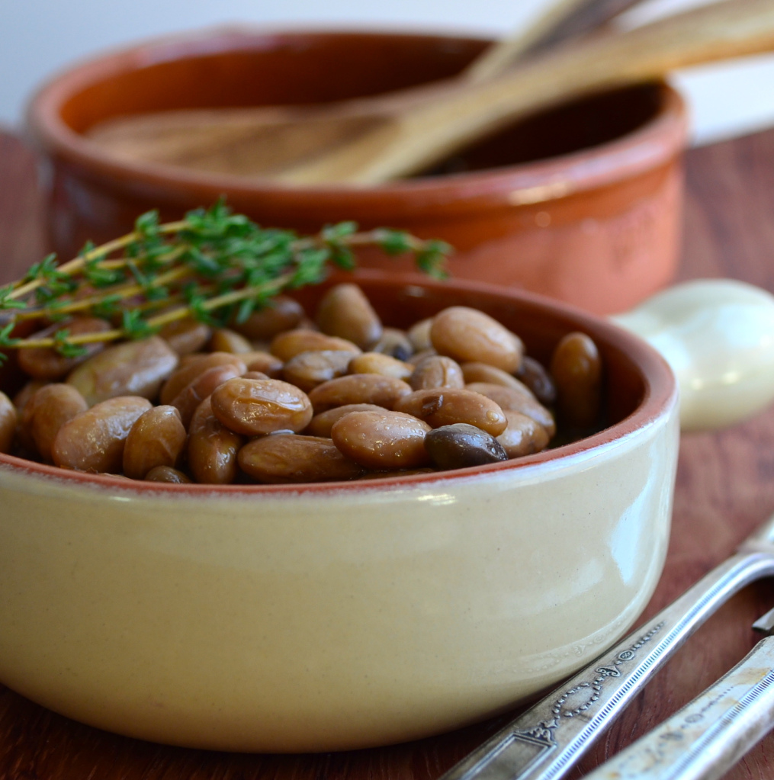](http://testmayihavethatrecipe.files.wordpress.com/2012/11/dsc_0081.jpg)

**ENJOY! From May I have that recipe**

**[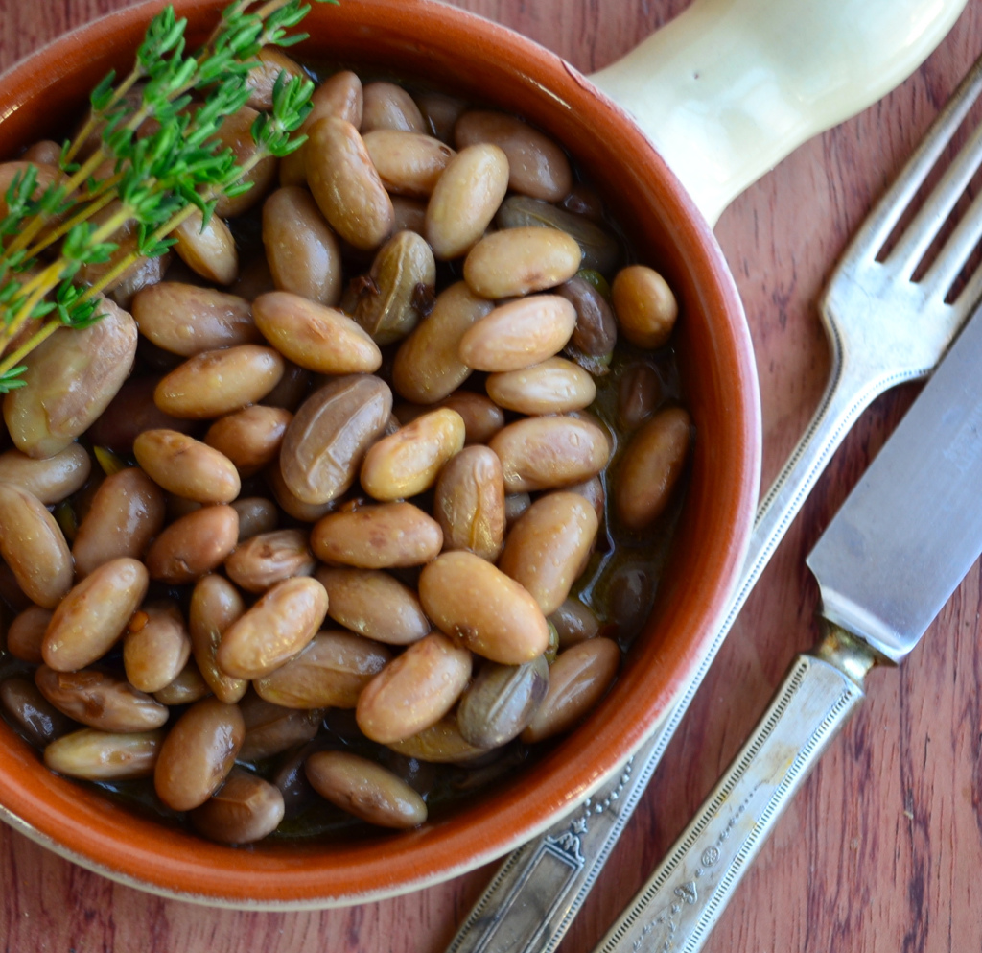](http://testmayihavethatrecipe.files.wordpress.com/2012/11/fresh-cranberry-beans-with-garlic.jpg)**

**You might also like:**